**CALL FOR ARTISTS**

**Public Safety Center**

**Community Engagement Room**

**Public Art Project**

**Reno, Nevada**

Deadline: May 31, 2024, at 11:00 pm PST

Budget: $25,000

**SUMMARY:**

Construction is currently underway for the new City of Reno Public Safety Center, which will soon serve as the headquarters for the Reno Police Department (RPD). The City of Reno is accepting qualifications from artists/artist teams for an interior public art installation located in the building’s Community Engagement Room. Part of this project includes a community engagement component. Selected artist(s) will be expected to work with City staff to conduct community engagement sessions with users of the building and the surrounding neighborhood. The final design of the artwork will be created from input from these sessions.

There are a total of five artist calls for distinct art needs and locations at the new Public Safety Center. You are invited to apply for as many as you are interested in and qualified for.

**ARTIST QUALIFICATIONS / ELIGIBILITY:**

This is a national call and request for qualifications. This project is open to any artist regardless of race, color, creed, gender, gender variance, national origin, age, religion, marital status, political opinion or affiliation, or mental or physical handicap. Artists may apply as a single artist or as a multi-person collaborative group. In the case of a group, please apply under one single application. Artists and teams working in the United States and who have experience implementing projects with a similar budget and scope are encouraged to apply.

* Artists age 18 or older may apply as an individual or a team
* Must be available for on-site visit to Reno
* Eligible applicants must reside in the United States

**PROJECT DESCRIPTION:**

The City of Reno is seeking artists for an interior public artwork in the Community Engagement Room at the new Public Safety Center. The City is looking for projects that take into consideration the history of the site and the unique characteristics of the surrounding environment.

The selection committee is looking for artwork that is appropriate for placement in the Community Engagement Room of the public safety facility and for the diverse Reno community. The theme of the artwork does not need to be directly connected to public safety functions and imagery, or to Reno history.

The artwork will be on two of the walls in the Community Engagement Room. Artwork will need to be 2D, which can include murals or framed/mounted artwork. See below for site images.

The goals for the project include: creating a unique character for a specific building, increasing public awareness of art, engaging with the community to create something that reflects the area and use of the space, and broadening visitors’ perspectives of public spaces within the City. The artist(s) selected should have demonstrated experience working in public locations.

The RACC seeks artists with prior public art experience, specifically 2D and mural work. The $25,000 commission will cover all services from design through final installation/implementation, including artist fee, fabrication, insurance, transportation, travel fees, equipment, and installation. Final selection of one artist or team will be made by the PAC, RACC, and stakeholders and approved by Reno City Council based on qualifications and proposal.

Selected artists/artist teams/design team will be expected to work with the community, City staff, and stakeholders to design the final artwork.

**LOCATION:**

[Google Maps Link](https://www.google.com/maps/place/955+Kuenzli+St,+Reno,+NV+89502/@39.5289358,-119.7971103,299m/data=!3m1!1e3!4m15!1m8!3m7!1s0x809940ada87fd403:0x5c204b554310512d!2sSutro+St+%26+Kuenzli+St,+Reno,+NV+89502!3b1!8m2!3d39.5283363!4d-119.7983548!16s%2Fg%2F11hb2gd3fl!3m5!1s0x809940ac58806ef7:0xf945587092786348!8m2!3d39.5289957!4d-119.7970656!16s%2Fg%2F11bw4mwv95?entry=ttu)

**ABOUT THE LOCATION:**

Located in the heart of our downtown, the building’s central location helps ensure RPD’s swift emergency response and makes it convenient for residents to access. The site was formerly home to the Reno Gazette-Journal. Renovating the existing building provides a more sustainable option, allowing the City to reduce waste while also preserving a rich piece of the Biggest Little City’s history.

From no dedicated public parking at the previous RPD station to approximately 50 public spaces, the Public Safety Center is designed to ease public access. Once inside, community members will be greeted by a large lobby, a public meeting space, and improved victim reporting areas.

Other notable features include:

* Four interview areas, including a family room
* Enhanced technology throughout the building
* 28,000 square feet of evidence storage
* Improved security and safety features
* Wellness amenities for staff to recreate and recharge such as a gym, sleeping rooms, and an inviting outdoor space
* Female-focused additions for employees like more women’s locker rooms and a private lactation room
* Sustainable design elements including rooftop solar

**BUDGET:**

Projected budget is not to exceed $25,000 for the entire project. This budget is inclusive of all costs associated with the design, planning, fabrication, installation, and completion of the project. This budget includes all travel costs and insurance.

**SELECTION PROCESS & CRITERIA:**

* The review committee will select three finalists to interview.
* The finalists will be invited to give a virtual presentation to the Public Art Committee to share more about their artistic process, past work, and plans, inspiration, and possible concept for this commission. Each finalist will receive an honorarium of $1,000 for the presentation and initial concept.
* The Public Art Committee, with input from stakeholders, and the RACC will select one artist/artist team for the $25,000 commission.
* City Council will have final approval.

Selection of a finalist will be based on the following criteria:

* Quality of letter of interest.
* Quality of work samples.
* Quality of initial concept.
* Ability to complete the project based on bio, previous work, and references.

Selected artists/design team will be expected to work with the community, City staff, and stakeholders to design the final artwork.

**SUBMISSION REQUIREMENTS:**

To be submitted via [Submittable](https://cityofrenoartscultureandevents.submittable.com/submit). (https://cityofrenoartscultureandevents.submittable.com/submit).

1. *Resume or CV:* Current professional resume or curriculum vitae (CV), detailing professional artistic accomplishments, including bio and artist address, email, and phone number. Submit information for all team members.
2. *Work Samples:* 5-10 images of recent previously completed artwork. Include title, year completed, materials/media, client, location, budget, and description of work.
3. *Letter of Interest:* Address how the applicant’s previous experience and current artistic direction will result in a successful public art project for this space. Include detailed information on how you would approach this project and how it will reflect the regional community.

**Estimated timeline:**

RFQ announced: May 1st, 2024

RFQ submission deadline: May 31, 2024 11:00 pm PST

June 2024: Committee review and selection of three finalists.

July 2024: Finalist Presentations

July/August 2024: Finalist artist/team selected for Project

August 2024: Artist/team will work with staff, community, Council, architect, and contractor to finalize designs for artwork via stakeholder meetings.

September 2024: Fabrication and installation.

All questions regarding this request for qualifications are to be directed to Megan Berner, Arts & Culture Manager, City of Reno at bernerm@reno.gov or 775-326-6333.

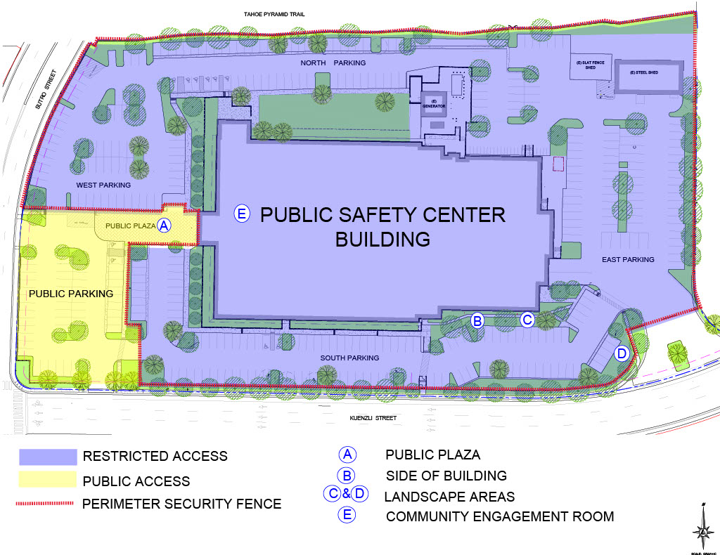

Installation Location Site E

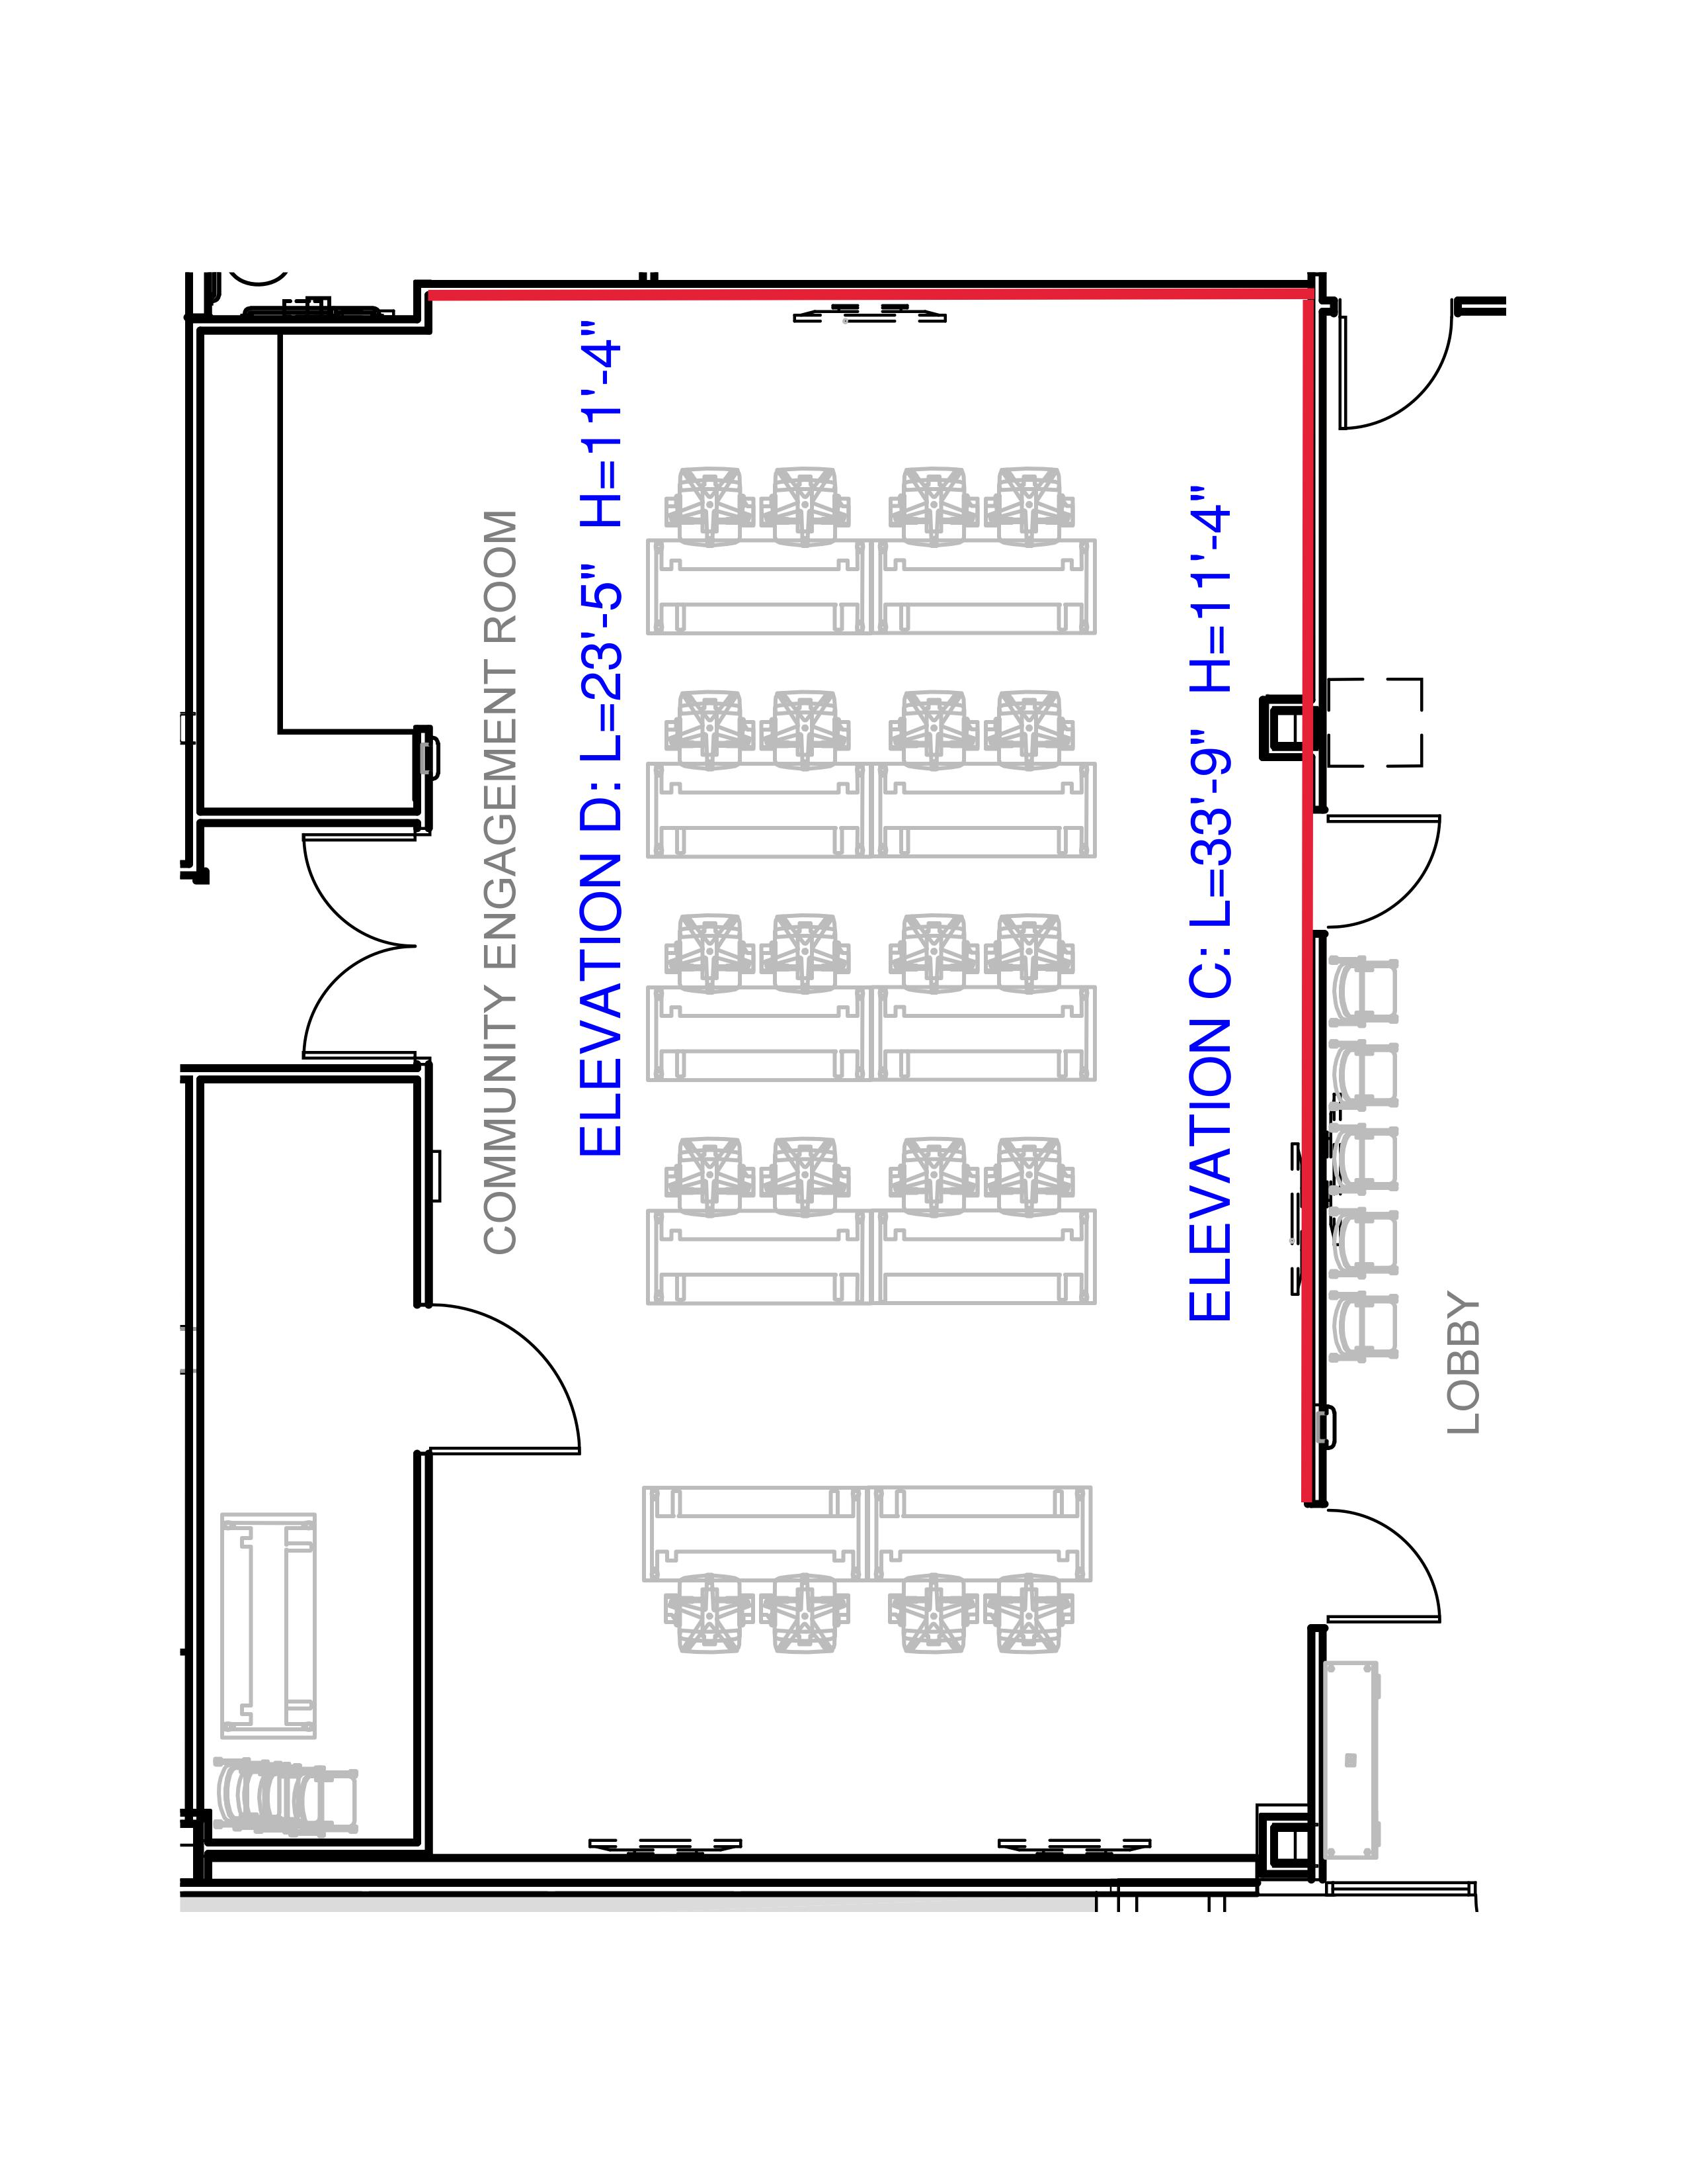

Map of Community Engagement Room with dimensions. Walls for art are highlighted in red.

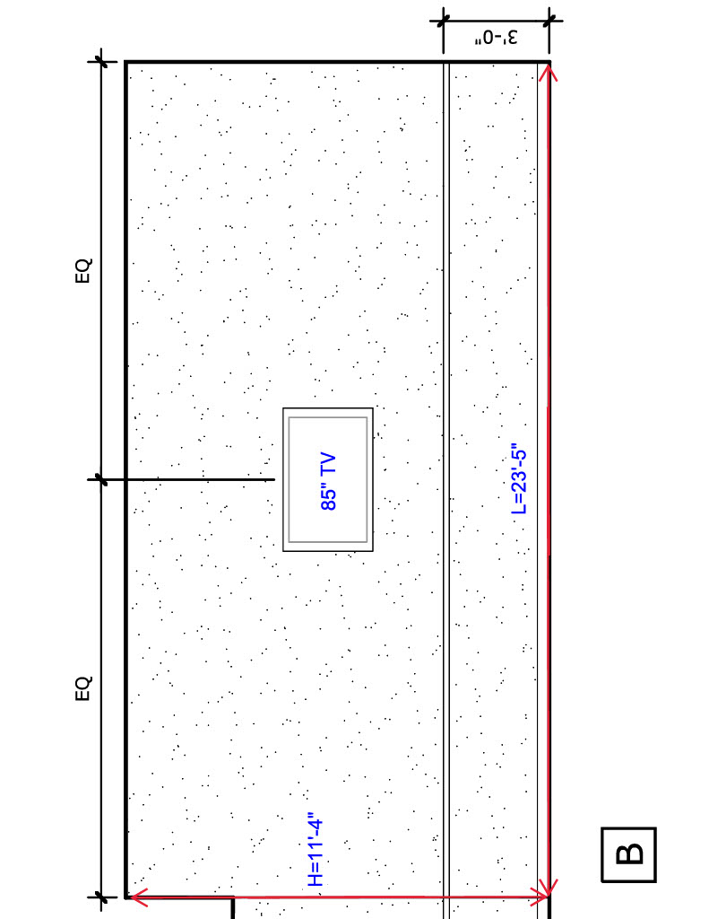

View of Wall B with dimensions

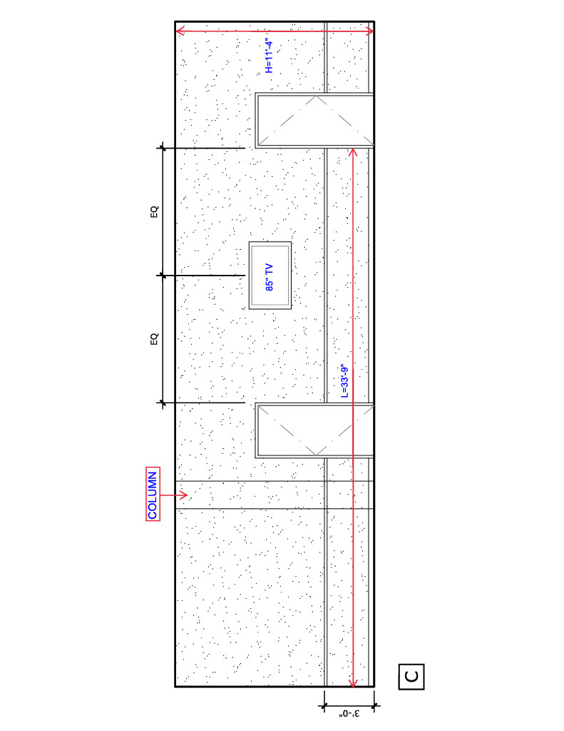

View of Wall C with dimensions